**CST-105: Exercise 4**

The following exercise assesses your ability to do the following:

* Design a logical solution using control structures.
* Utilize repetition structures in a programming solution.
* Use file input and output operations in a programming solution

1. Review the rubric for this assignment before beginning work. Be sure you are familiar with the criteria for successful completion. The rubric link can be found in the digital classroom under the assignment.
2. Design a flowchart for a program that tabulates contributions collected by an organization. The organization wishes to accept contributions until a total of $10,000,000 is met. Once this total is hit, no further contributions should be accepted.   
     
   The organization wants the program to read data from an input file (input.in). The following data should be written to a file called results.out
   1. The total number of contributions needed to meet the goal of 10 million dollars
   2. The amount of the largest and smallest contribution accepted
   3. The average contribution size
   4. The final total of the contributions accepted
3. 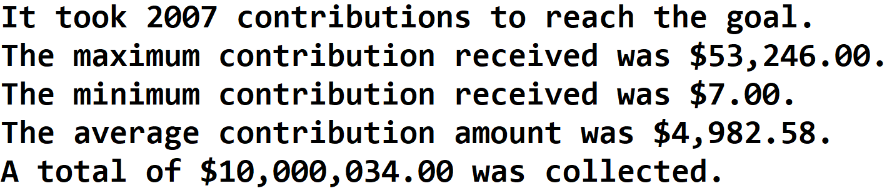Implement (code) and test your program with a variety of input data. It is helpful to set a smaller contribution goal when testing your program. Consider both the scenario where the input file does not contain enough contributions to meet the goal and the scenario where the input file contains more data than needed. The output file should match the formatting shown in the example.
4. Make a video of your project. In your video, run your program and discuss your solution, being sure to explain any interesting computations. Your video should not exceed 3 minutes.

Submit the following in the digital classroom, as directed by your instructor:

* Your flowchart (.png file)
* A text file that contains
  + A link to your video
  + Your .java code